RAINFALL PREDICTION USING REGRESSION MODEL
ABSTRACT
Regression is been widely used in all the applications and weather forecasting is not an exception. When it comes to weather forecasting, rainfall prediction is one of the most widely used research areas as numerous lives and property damages occur due to this. Intense rainfall has abundant impacts on society and on our daily life from cultivation to disaster measures. Previous rainfall prediction models that are widely used, makes use of many the complicated blend of mathematical instruments which was insufficient to get a higher classification rate. In this project, we propose new novel methods for predicting monthly rainfall using regression analysis. Rainfall predictions are made by collecting quantitative data about the current state of the atmosphere. Numerous machine learning algorithms can learn complex mappings from inputs to outputs, based solely on samples and require limited. Accurate prediction of rainfall is a difficult task due to the dynamic nature of the atmosphere. To predict the future’s rainfall condition, the variation in the conditions in past years must be utilized. We have proposed the use of Random Forests by making use of various parameters such as temperature, humidity,and wind. The proposed model tends to forecast rainfall based on the previous records of a particular geographic area, therefore, this prediction will prove to be much reliable. The performance of the model is more accurate when compared with traditional rainfall prediction systems.

INTRODUCTION
Immense growth in the research area of Artificial Intelligence has given birth to many new technologies that make use of numerous features of the and some of them are Machine Learning Approaches and Deep Learning Techniques. Machine learning techniques are widely used in numerous applications such as medical image analysis [1], robot path planning [2], flood detection in a particular city or area [3] and land cover classification [4].
Machine learning technique is a process of learning a specific task without any human intervention and improving the performance only by the continuous learning process. The learning is of two types: supervised learning [5], where the labeling is given for the features of the training dataset and unsupervised learning [6], where no labels are given and the system needs to label the features of the dataset. Feature extraction is a vital process in all the machine learning approaches [21,22]. The extracted features could then be used for various other approaches like classification or regression. Some of the widely used classifiers in machine learning techniques are SVM classifiers [7], Decision Trees [8], Naive Bayes [9] and Random Forest [10] and Random Forest Trees [11]. When larger datasets are being used in an application then the use of Artificial Neural Networks (ANNs) is preferred for feature extraction as it produces more accurate results [12]. Use of ANNs is widely called Deep Learning Approaches as the neural network learns each and every layer very deeply and uses the output of a layer as the input of the next layer. ANNs serves as a classifier resembling the function of a biological neuron having numerous layers connected to each other through weights [13]. In image processing, the number of pixels (picture elements) depends upon the input image. The image is the replica of reality which provides as much information as possible about an object. The arrangement of neurons forming layers and the connection patterns formed within and between each layer is called Network Structures. ANNs are information processing structures thatcan solve any problem through learned examples rather than pre-specified algorithms [14]. In this paper, we have made use of random forest regression for classifying the input data and predicting the occurrence of rainfall. The proposed model would serve a model predicting the rainfall beforehand to reduce various impacts on society and to make predictive measures for disaster reliefs. The Random Forest techniqueisused to classify the images and predict the rainfall. The rest of the section is as follows: Section II consists of Literature Survey, section III consists of the methodology used in the paper and section III consists of various results obtained. The paper is concluded in the last by mentioning the relevant future works that could be applied or added to the proposed work.

MAIN OBJECTIVES
- To develop an accurate rainfall prediction model
The primary objective is to design and train a regression-based machine learning model that can predict rainfall using key weather parameters such as temperature, humidity, and wind speed. The model aims to enhance prediction accuracy compared to conventional forecasting methods.
- To implement a user-friendly web application using Flask
Build a Flask-based web application where users can input real-time or historical weather data parameters and receive instant rainfall predictions, allowing easy accessibility and practical usability for non-technical users.
- To support proactive planning for weather-dependent activities
Enable timely and reliable rainfall forecasts to assist in agriculture, disaster management, and urban planning by providing precise predictions based on historical weather data and regression analysis.

SCOPE OF THE PROJECT
The scope of this project is to develop a reliable and efficient rainfall prediction system using regression-based machine learning techniques, aimed at minimizing the risks associated with unexpected weather changes. By analyzing historical weather data, including parameters such as temperature, humidity, and wind speed, the model learns to predict rainfall patterns for a specific geographic region. The project further extends its utility by integrating the trained model into a user-friendly Flask web application, allowing users to input real-time atmospheric data and obtain instant rainfall predictions. This system can assist farmers in planning agricultural activities, help city planners prepare for drainage and flood prevention, and enable early disaster preparedness for extreme weather conditions. The project offers scalability for future improvements by allowing the addition of more complex datasets or advanced machine learning techniques, making it a practical solution for both small and large-scale weather monitoring applications.

LITERATURE SURVEY

1. Prediction of Rainfall Using Machine Learning Algorithms
- Authors: A. G. M. S. R. Lakshmi, M. M. A. S. S. M. R. Murugan
- Published in: International Journal of Engineering Research and Technology, 2016
- Summary: This paper discusses the use of machine learning algorithms such as Random Forest, Support Vector Machines, and Artificial Neural Networks (ANNs) for rainfall prediction. The study concludes that machine learning models can outperform traditional statistical methods in terms of prediction accuracy by learning complex, non-linear relationships in weather data.

2. A Comparative Study of Weather Forecasting Models: Machine Learning Approaches
- Authors: B. T. Viswanathan, S. S. V. G. R. N. Reddy
- Published in: Journal of Climate Change, 2019
- Summary: This research evaluates multiple machine learning techniques for weather forecasting, focusing on rainfall prediction. The study compares various algorithms like Random Forest, Decision Trees, and Neural Networks, highlighting their strengths and weaknesses in terms of prediction accuracy, time complexity, and data dependency.

3. Rainfall Prediction Using Regression Models
- Authors: R. S. Gajbhiye, A. A. Yawale, P. S. Raut
- Published in: International Journal of Computer Science and Information Technologies, 2017
- Summary: This paper presents a rainfall prediction system using Random Forest and decision trees. The research focuses on utilizing historical weather data (temperature, humidity, and wind speed) to train the regression models and suggests a hybrid approach to improve prediction accuracy by combining multiple regression models.

4. Rainfall Prediction with Machine Learning: A Case Study in Agricultural Planning
- Authors: H. Patel, S. Yadav
- Published in: International Journal of Agricultural Sciences, 2020
- Summary: This paper explores the application of machine learning techniques, including Random Forest, for predicting rainfall patterns in regions dependent on agriculture. The authors demonstrate how rainfall predictions can enhance crop yield predictions and help farmers plan better.

5. Deep Learning for Weather Forecasting: A Review
- Authors: Y. Y. W. Tan, H. P. Lau, K. L. Lee
- Published in: Computers, Environment and Urban Systems, 2019
- Summary: This review article examines the use of deep learning models in weather forecasting, particularly focusing on rainfall prediction. The authors highlight the effectiveness of Convolutional Neural Networks (CNNs) and Long Short-Term Memory (LSTM) networks for learning temporal patterns in weather data, showing promising results in predicting rainfall in specific geographic areas.

6. Data-Driven Rainfall Prediction using Regression Analysis
- Authors: A. K. Gupta, R. Verma
- Published in: Journal of Hydrology, 2018
- Summary: This paper focuses on using regression analysis techniques for rainfall prediction. It explores the relationship between various meteorological parameters and rainfall data. The study shows that Random Forest can provide satisfactory results for short-term rainfall prediction, especially when data is available for a specific geographical region.

EXISTING SYSTEM
Traditionally, rainfall prediction systems relied heavily on meteorological models that integrate a complex mix of mathematical formulas, atmospheric data, and expert knowledge. These models often use statistical methods and historical weather patterns to forecast rainfall. However, these systems have limitations, including reliance on large-scale, high-resolution datasets that may not always be readily available or accurate. Many traditional methods, such as weather station-based models, often fail to account for real-time, localized variations in weather conditions. Moreover, these systems require extensive manual adjustments and are often slow, which limits their real-time applicability in emergency or time-sensitive scenarios. While there have been advancements in using machine learning for weather prediction, these methods have often been cumbersome or lacked user-friendly interfaces for easy accessibility.

PROPOSED SYSTEM
The proposed system aims to modernize rainfall prediction by using regression-based machine learning algorithms that are trained on historical weather data, including parameters like temperature, humidity, and wind speed. This model will be able to predict rainfall with greater accuracy by learning from past patterns, eliminating the need for complex manual interventions. The core of the system lies in its integration into a Flask-based web application, where users can simply enter their current weather parameters (such as temperature, humidity, and wind speed) to receive instant rainfall predictions. This makes the system accessible, fast, and practical for non-expert users, such as farmers, urban planners, and anyone requiring accurate weather predictions. Additionally, the system can be improved over time by incorporating more features or data, enhancing its predictive capabilities. The web-based application ensures ease of use, scalability, and the potential for real-time updates, making it a much-needed tool for proactive weather-related decision-making.

METHODOLOGY
The methodology for this Rainfall Prediction System involves several key stages: data collection, model training, application development, and deployment. Below is a step-by-step breakdown of how the system is developed:

1. Data Collection
- Data Sources: Historical weather data, including parameters such as temperature, humidity, wind speed, and rainfall (historical rainfall records), is collected from various sources like government weather stations, open datasets, or API services.
- Data Preprocessing: The collected data is cleaned to handle any missing values, outliers, or inconsistencies. Features like temperature, humidity, and wind speed are extracted, and the dataset is normalized to ensure consistency in scale for input parameters.

2. Feature Selection and Engineering
- Feature Selection: Key meteorological parameters such as temperature, humidity, and wind speed are selected based on their relevance to rainfall prediction.
- Feature Engineering: Additional features can be derived from the existing data, such as historical rainfall patterns, moving averages, or seasonal trends. This helps in improving the model’s accuracy by adding more context to the data.

3. Model Training
- Model Choice: A Random Forest model is selected as the core model for predicting rainfall. Random forest is chosen due to its simplicity and effectiveness in predicting continuous outcomes based on a relationship between input features and the target variable (rainfall).
- Model Training: Using historical data, the Random Forest model is trained to map the relationships between input parameters (temperature, humidity, wind speed) and the target variable (rainfall). A training dataset (e.g., 70% of the total dataset) is used to fit the model, while the remaining 30% is used for testing and validation.

4. Flask Web Application Development
- Backend Development: The trained model is integrated into a Flask web application using Python. The backend logic ensures that the user inputs are collected, processed, and fed into the regression model to predict rainfall.
- User Interface (UI): A simple and intuitive UI is developed where users can input real-time data such as temperature, humidity, and wind speed. The application will display the predicted rainfall based on these inputs.

5. Testing and Validation
- Validation: The model is tested with previously unseen data (the test set) to evaluate how well it generalizes to new inputs. Any overfitting issues are addressed through regularization or cross-validation techniques.
- User Testing: The Flask application is tested with real users to ensure the user interface is functional and that the rainfall prediction is accurate and reliable.

6. Deployment and Integration
- Deployment: The trained model and the Flask application are deployed to a web server, allowing users to access the rainfall prediction system through a web browser.
- Monitoring: After deployment, continuous monitoring is conducted to assess the system’s performance and make adjustments if necessary (e.g., retraining the model with new data).

7. Future Enhancements
- Model Improvement: Future versions of the system may integrate more advanced machine learning algorithms, such as Support Vector Machines (SVM), to enhance prediction accuracy. Deep learning models (like LSTM networks) can also be explored to capture complex temporal relationships in rainfall data.
- Additional Features: More input parameters like geographical information, cloud cover, or historical trends can be incorporated to refine predictions further. The system can be enhanced to provide hourly or weekly forecasts.

This methodology outlines a structured approach to developing an effective and user-friendly Rainfall Prediction System using regression models and Flask. The combination of data collection, model training, web application development, and deployment ensures a comprehensive solution that can be easily accessed and used for weather prediction and planning.

SOFTWARE AND HARDWARE REQUIREMENTS
SOFTWARE REQUIREMENTS
OPERATING SYSTEM | WINDOWS 10
LANGUAGE | PYTHON, HTML, CSS
IDE | PYTHON IDLE 3.8
FRAME WORK | FLASK

HARDWARE REQUIREMENTS
RAM | 4GB
ROM | ANY DEFAULT
PROCESSOR | I3 MINIMUM

DESIGN
ARCHITECTURE

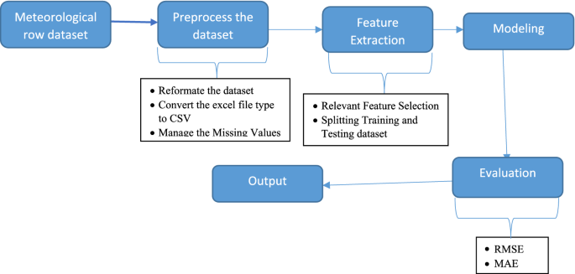

1. Meteorological Raw Dataset
- This is your original weather data, usually in Excel format.
- It contains values like temperature, humidity, wind speed, etc.

2. Preprocess the Dataset
- Before using the data for prediction, it needs to be cleaned and prepared:
  - Reformat the dataset to make it usable.
  - Convert Excel to CSV format.
  - Handle missing values (for example, fill them with average values).

3. Feature Extraction
- Select only the most important columns (features) from the data that affect rainfall.
- Split the data into two parts:
  - Training data to train the model.
  - Testing data to test how well the model works.

4. Modeling
- Apply a Random Forest model (or any other machine learning model) on the training data to learn patterns.

5. Evaluation
- Test the model on the testing data and check how accurate it is using metrics like:
  - RMSE (Root Mean Squared Error)
  - MAE (Mean Absolute Error)

6. Output
- The model now gives predictions of rainfall based on new weather data.

FLOW CHART
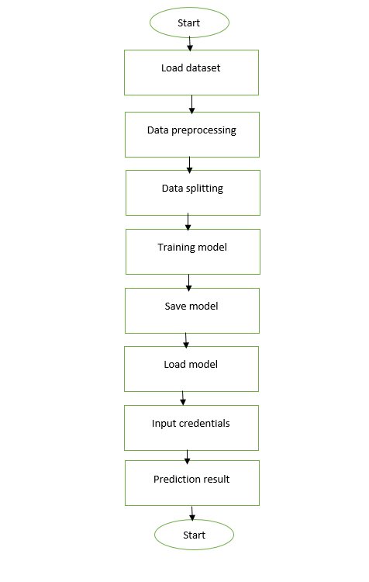

IMPLEMENTATION / ABOUT TOOLS AND TECHNOLOGIES USED
ABOUT PYTHON
Python offers concise and readable code. While complex algorithms and versatile workflows stand behind machine learning and AI, Python’s simplicity allows developers to write reliable systems. Developers get to put all their effort into solving an ML problem instead of focusing on the technical nuances of the language.
Additionally, Python is appealing to many developers as it’s easy to learn. Python code is understandable by humans, which makes it easier to build models for machine learning.
Many programmers say that Python is more intuitive than other programming languages. Others point out the many frameworks, libraries, and extensions that simplify the implementation of different functionalities. It’s generally accepted that Python is suitable for collaborative implementation when multiple developers are involved. Since Python is a general-purpose language, it can do a set of complex machine learning tasks and enable you to build prototypes quickly that allow you to test your product for machine learning purposes.

Platform independence
Platform independence refers to a programming language or framework allowing developers to implement things on one machine and use them on another machine without any (or with only minimal) changes. One key to Python’s popularity is that it’s a platform independent language. Python is supported by many platforms including Linux, Windows, and macOS. Python code can be used to create standalone executable programs for most common operating systems, which means that Python software can be easily distributed and used on those operating systems without a Python interpreter.
What’s more, developers usually use services such as Google or Amazon for their computing needs. However, you can often find companies and data scientists who use their own machines with powerful Graphics Processing Units (GPUs) to train their ML models. And the fact that Python is platform independent makes this training a lot cheaper and easier.

Great community and popularity
In the Developer Survey 2018 by Stack Overflow, Python was among the top 10 most popular programming languages, which ultimately means that you can find and hire a development company with the necessary skill set to build your AI-based project.
If you look closely at the image below, you’ll see that Python is the language that people Google more than any other.

PYTHON INSTALLATION
Python is a widely used high-level programming language. To write and execute code in python, we first need to install Python on our system.
Installing Python on Windows takes a series of few easy steps.

Step 1 − Select Version of Python to Install
Python has various versions available with differences between the syntax and working of different versions of the language. We need to choose the version which we want to use or need. There are different versions of Python 2 and Python 3 available.

Step 2 − Download Python Executable Installer
On the web browser, in the official site of python (www.python.org), move to the Download for Windows section.
All the available versions of Python will be listed. Select the version required by you and click on Download. Let suppose, we chose the Python 3.9.1 version.
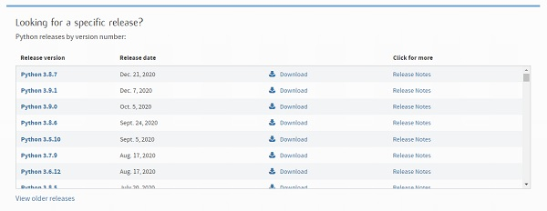
On clicking download, various available executable installers shall be visible with different operating system specifications. Choose the installer which suits your system operating system and download the instlaller. Let suppose, we select the Windows installer(64 bits).
The download size is less than 30MB.
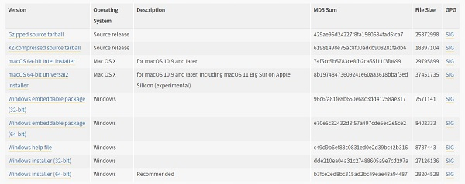

Step 3 − Run Executable Installer
We downloaded the Python 3.9.1 Windows 64 bit installer.
Run the installer. Make sure to select both the checkboxes at the bottom and then click Install New.
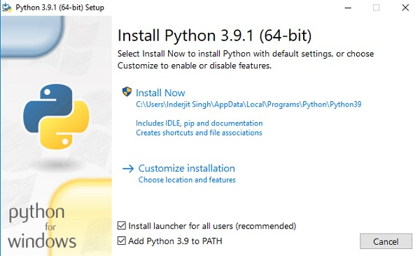
On clicking the Install Now, The installation process starts.
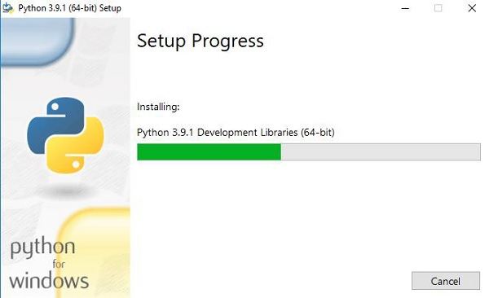
The installation process will take few minutes to complete and once the installation is successful, the following screen is displayed.
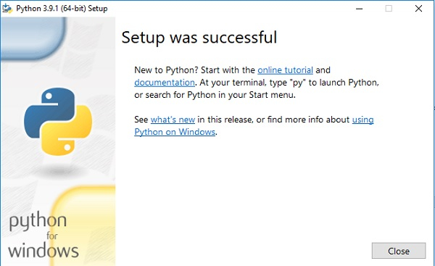

Step 4 − Verify Python is installed on Windows
To ensure if Python is succesfully installed on your system. Follow the given steps −
- Open the command prompt.
- Type ‘python’ and press enter.
- The version of the python which you have installed will be displayed if the python is successfully installed on your windows.
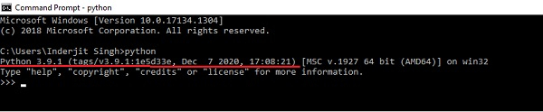

Step 5 − Verify Pip was installed
Pip is a powerful package management system for Python software packages. Thus, make sure that you have it installed.
To verify if pip was installed, follow the given steps −
- Open the command prompt.
- Enter pip –V to check if pip was installed.
- The following output appears if pip is installed successfully.
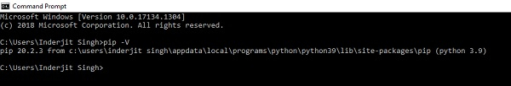
We have successfully installed python and pip on our Windows system.

To install any libraries
Go to command prompt
Type
Pip install libraryname

FLASK

What is Flask Python
Flask is a web framework, it’s a Python module that lets you develop web applications easily. It’s has a small and easy-to-extend core: it’s a microframework that doesn’t include an ORM (Object Relational Manager) or such features.
It does have many cool features like url routing, template engine. It is a WSGI web app framework.

What is a Web Framework?
A Web Application Framework or a simply a Web Framework represents a collection of libraries and modules that enable web application developers to write applications without worrying about low-level details such as protocol, thread management, and so on.

What is Flask?
Flask is a web application framework written in Python. It was developed by Armin Ronacher, who led a team of international Python enthusiasts called Poocco. Flask is based on the Werkzeg WSGI toolkit and the Jinja2 template engine.Both are Pocco projects.

WSGI
The Web Server Gateway Interface (Web Server Gateway Interface, WSGI) has been used as a standard for Python web application development. WSGI is the specification of a common interface between web servers and web applications.

Werkzeug
Werkzeug is a WSGI toolkit that implements requests, response objects, and utility functions. This enables a web frame to be built on it. The Flask framework uses Werkzeg as one of its bases.

jinja2
jinja2 is a popular template engine for Python.A web template system combines a template with a specific data source to render a dynamic web page.
This allows you to pass Python variables into HTML templates like this:
<html>
<head>
<title>{{ title }}</title>
</head>
<body>
<h1>Hello {{ username }}</h1>
</body>
</html>

Microframework
Flask is often referred to as a microframework. It is designed to keep the core of the application simple and scalable.
Instead of an abstraction layer for database support, Flask supports extensions to add such capabilities to the application.

Why is Flask a good web framework choice?
Unlike the Django framework, Flask is very Pythonic. It’s easy to get started with Flask, because it doesn’t have a huge learning curve.
On top of that it’s very explicit, which increases readability. To create the “Hello World” app, you only need a few lines of code.
This is a boilerplate code example.
from flask import Flask
app = Flask(__name__)
@app.route('/')
def hello_world():
return 'Hello World!'
if __name__ == '__main__':
app.run()
If you want to develop on your local computer, you can do so easily. Save this program as server.py and run it with python server.py.
$ python server.py
* Serving Flask app "hello"
* Running on http://127.0.0.1:5000/ (Press CTRL+C to quit)
It then starts a web server which is available only on your computer. In a web browser open localhost on port 5000 (the url) and you’ll see “Hello World” show up.
To host and develop online, you can use PythonAnywhere
Some example output:
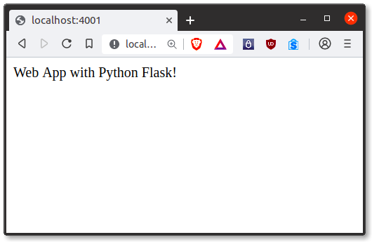
It’s a microframework, but that doesn’t mean your whole app should be inside one single Python file. You can and should use many files for larger programs, to handle complexity.
Micro means that the Flask framework is simple but extensible. You may all the decisions: which database to use, do you want an ORM etc, Flask doesn’t decide for you.
Flask is one of the most popular web frameworks, meaning it’s up-to-date and modern. You can easily extend it’s functionality. You can scale it up for complex applications

HTML
Hypertext Markup Language (HTML) is the standard markup language for creating web pages and web applications. With Cascading Style Sheets (CSS) and JavaScript, it forms a triad of cornerstone technologies for the World Wide Web.
Web browsers receive HTML documents from a web server or from local storage and render the documents into multimedia web pages. HTML describes the structure of a web page semantically and originally included cues for the appearance of the document.
HTML elements are the building blocks of HTML pages. With HTML constructs, images and other objects such as interactive forms may be embedded into the rendered page. HTML provides a means to create structured documents by denoting structural semantics for text such as headings, paragraphs, lists, links, quotes and other items. HTML elements are delineated by tags, written using angle brackets. Tags such as <img /> and <input /> directly introduce content into the page. Other tags such as <p> surround and provide information about document text and may include other tags as sub-elements. Browsers do not display the HTML tags, but use them to interpret the content of the page.
HTML can embed programs written in a scripting language such as JavaScript, which affects the behavior and content of web pages. Inclusion of CSS defines the look and layout of content. The World Wide Web Consortium (W3C), maintainer of both the HTML and the CSS standards, has encouraged the use of CSS over explicit presentational HTML since 1997.
CSS
Cascading Style Sheets (CSS) is a style sheet language used for describing the presentation of a document written in a markup language like HTML. CSS is a cornerstone technology of the World Wide Web, alongside HTML and JavaScript.
CSS is designed to enable the separation of presentation and content, including layout, colors, and fonts. This separation can improve content accessibility, provide more flexibility and control in the specification of presentation characteristics, enable multiple web pages to share formatting by specifying the relevant CSS in a separate .css file, and reduce complexity and repetition in the structural content.
Separation of formatting and content also makes it feasible to present the same markup page in different styles for different rendering methods, such as on-screen, in print, by voice (via speech-based browser or screen reader), and on Braille-basedtactile devices. CSS also has rules for alternate formatting if the content is accessed on a mobile device.
The name cascading comes from the specified priority scheme to determine which style rule applies if more than one rule matches a particular element. This cascading priority scheme is predictable.
The CSS specifications are maintained by the World Wide Web Consortium (W3C). Internet media type (MIME type) text/css is registered for use with CSS by RFC 2318 (March 1998). The W3C operates a free CSS validation service for CSS documents.
In addition to HTML, other markup languages support the use of CSS, including XHTML, plain XML, SVG, and XUL.

RANDOM FOREST

Introduction
Random forest is a Supervised Machine Learning Algorithm that is used widely in Classification and Regression problems. It builds decision trees on different samples and takes their majority vote for classification and average in case of regression.
One of the most important features of the Random Forest Algorithm is that it can handle the data set containing continuous variables as in the case of regression and categorical variables as in the case of classification. It performs better results for classification problems.

Real Life Analogy
Let’s dive into a real-life analogy to understand this concept further. A student named X wants to choose a course after his 10+2, and he is confused about the choice of course based on his skill set. So he decides to consult various people like his cousins, teachers, parents, degree students, and working people. He asks them varied questions like why he should choose, job opportunities with that course, course fee, etc. Finally, after consulting various people about the course he decides to take the course suggested by most of the people.
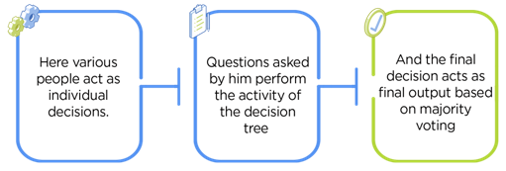

Working of Random Forest Algorithm
Before understanding the working of the random forest we must look into the ensemble technique. Ensemble simply means combining multiple models. Thus a collection of models is used to make predictions rather than an individual model.
Ensemble uses two types of methods:
1. Bagging– It creates a different training subset from sample training data with replacement & the final output is based on majority voting. For example, Random Forest.
2. Boosting– It combines weak learners into strong learners by creating sequential models such that the final model has the highest accuracy. For example, ADA BOOST, XG BOOST
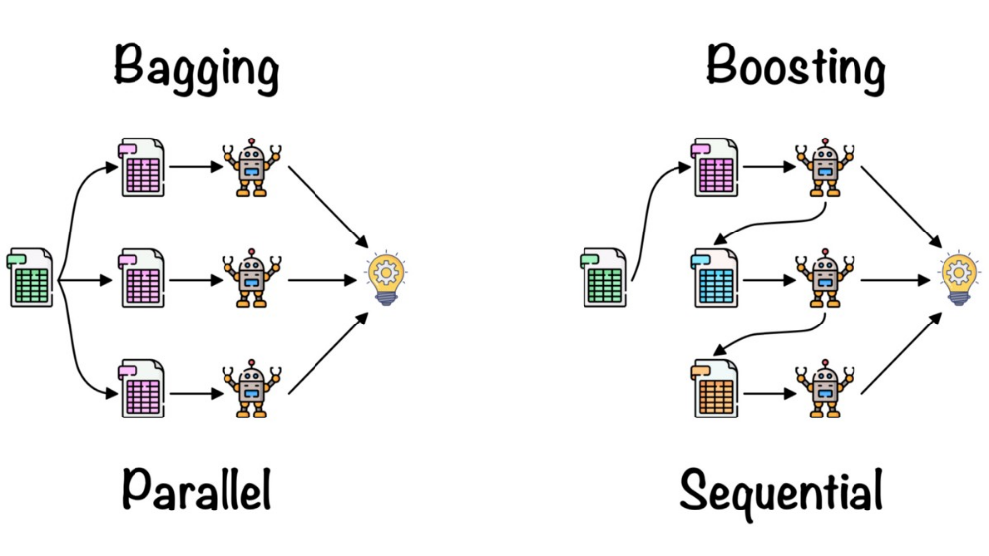
As mentioned earlier, Random forest works on the Bagging principle. Now let’s dive in and understand bagging in detail.

Bagging
Bagging, also known as Bootstrap Aggregation is the ensemble technique used by random forest. Bagging chooses a random sample from the data set. Hence each model is generated from the samples (Bootstrap Samples) provided by the Original Data with replacement known as row sampling. This step of row sampling with replacement is called bootstrap. Now each model is trained independently which generates results. The final output is based on majority voting after combining the results of all models. This step which involves combining all the results and generating output based on majority voting is known as aggregation.

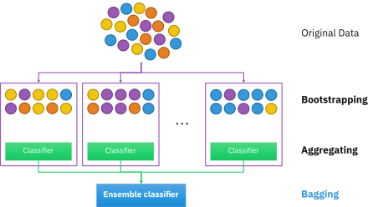
Now let’s look at an example by breaking it down with the help of the following figure. Here the bootstrap sample is taken from actual data (Bootstrap sample 01, Bootstrap sample 02, and Bootstrap sample 03) with a replacement which means there is a high possibility that each sample won’t contain unique data. Now the model (Model 01, Model 02, and Model 03) obtained from this bootstrap sample is trained independently. Each model generates results as shown. Now Happy emoji is having a majority when compared to sad emoji. Thus based on majority voting final output is obtained as Happy emoji.

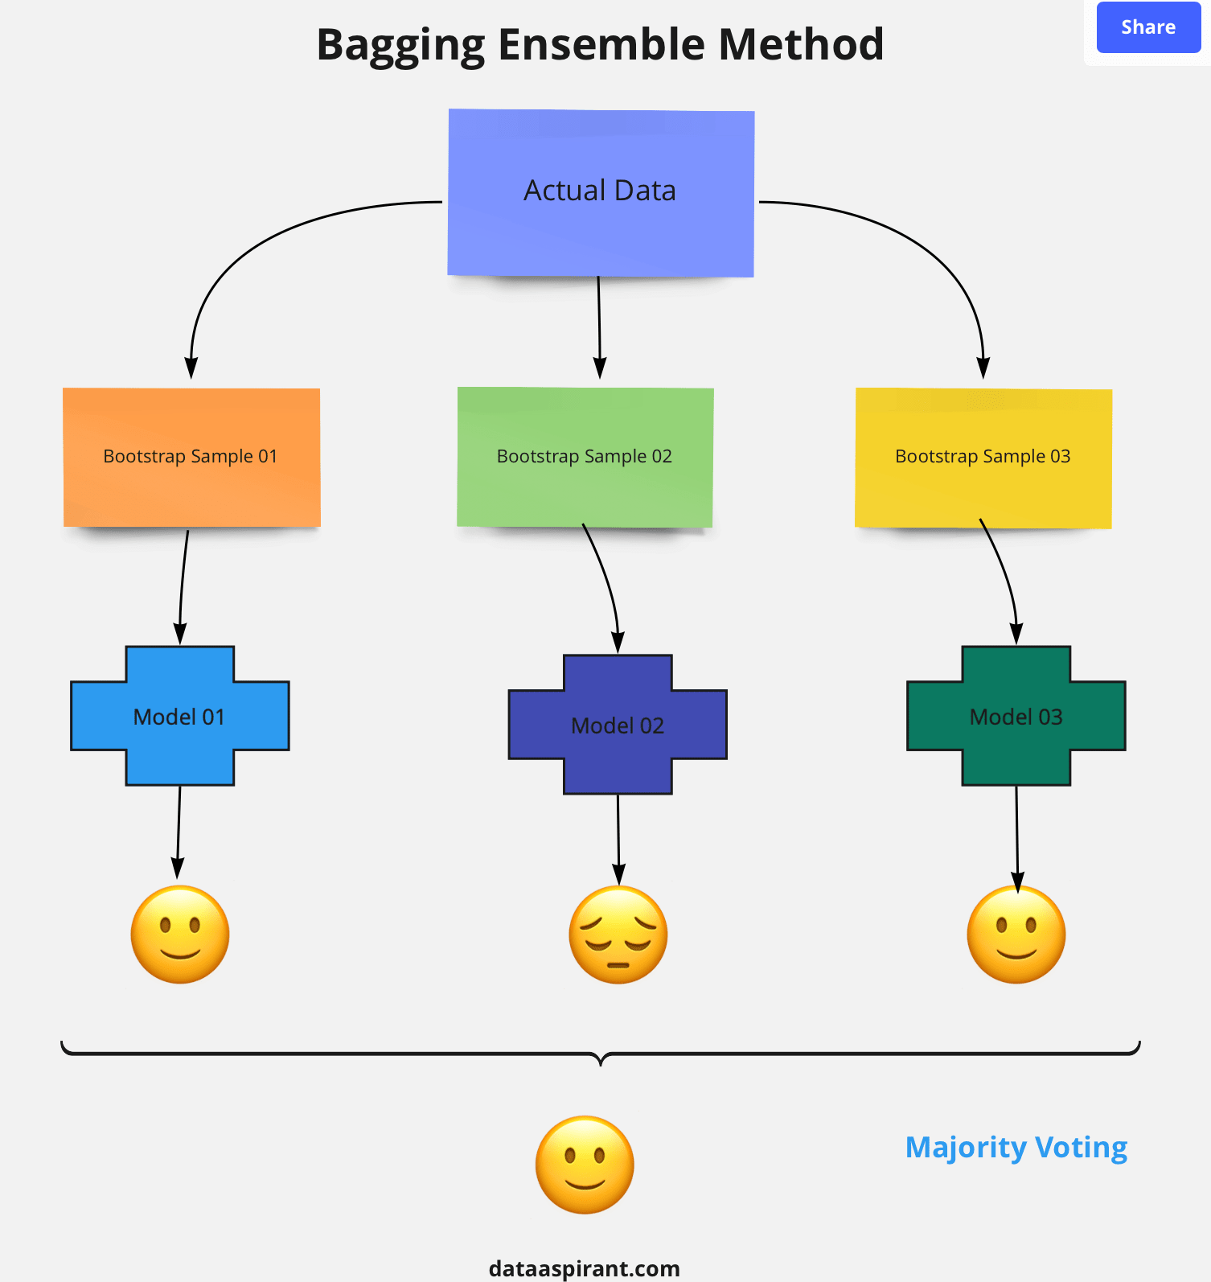

Steps involved in random forest algorithm:
Step 1: In Random forest n number of random records are taken from the data set having k number of records.
Step 2: Individual decision trees are constructed for each sample.
Step 3: Each decision tree will generate an output.
Step 4: Final output is considered based on Majority Voting or Averaging for Classification and regression respectively.
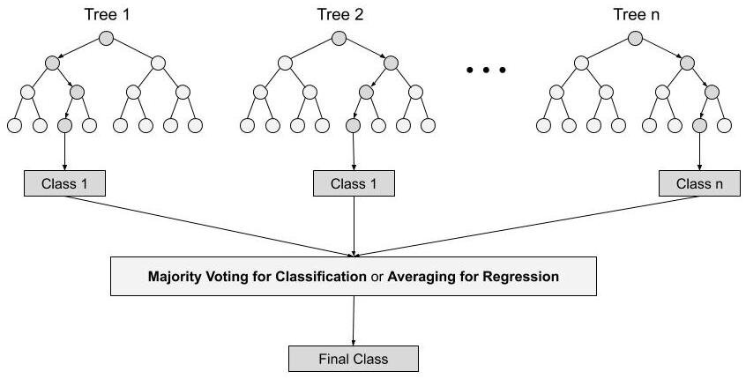
For example: consider the fruit basket as the data as shown in the figure below. Now n number of samples are taken from the fruit basket and an individual decision tree is constructed for each sample. Each decision tree will generate an output as shown in the figure. The final output is considered based on majority voting. In the below figure you can see that the majority decision tree gives output as an apple when compared to a banana, so the final output is taken as an apple.
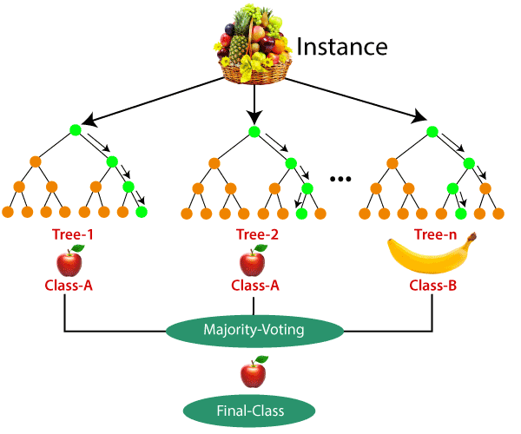

Important Features of Random Forest
1. Diversity- Not all attributes/variables/features are considered while making an individual tree, each tree is different.
2. Immune to the curse of dimensionality- Since each tree does not consider all the features, the feature space is reduced.
3. Parallelization-Each tree is created independently out of different data and attributes. This means that we can make full use of the CPU to build random forests.
4. Train-Test split- In a random forest we don’t have to segregate the data for train and test as there will always be 30% of the data which is not seen by the decision tree.
5. Stability- Stability arises because the result is based on majority voting/ averaging.

Difference Between Decision Tree & Random Forest
Random forest is a collection of decision trees; still, there are a lot of differences in their behavior.
Decision trees | Random Forest
1. Decision trees normally suffer from the problem of overfitting if it’s allowed to grow without any control. | 1. Random forests are created from subsets of data and the final output is based on average or majority ranking and hence the problem of overfitting is taken care of.
2. A single decision tree is faster in computation. | 2. It is comparatively slower.
3. When a data set with features is taken as input by a decision tree it will formulate some set of rules to do prediction. | 3. Random forest randomly selects observations, builds a decision tree and the average result is taken. It doesn’t use any set of formulas.
Thus random forests are much more successful than decision trees only if the trees are diverse and acceptable.

Important Hyperparameters
Hyperparameters are used in random forests to either enhance the performance and predictive power of models or to make the model faster.
Following hyperparameters increases the predictive power:
1. n_estimators– number of trees the algorithm builds before averaging the predictions.
2. max_features– maximum number of features random forest considers splitting a node.
3. mini_sample_leaf– determines the minimum number of leaves required to split an internal node.
Following hyperparameters increases the speed:
1. n_jobs– it tells the engine how many processors it is allowed to use. If the value is 1, it can use only one processor but if the value is -1 there is no limit.
2. random_state– controls randomness of the sample. The model will always produce the same results if it has a definite value of random state and if it has been given the same hyperparameters and the same training data.
3. oob_score – OOB means out of the bag. It is a random forest cross-validation method. In this one-third of the sample is not used to train the data instead used to evaluate its performance. These samples are called out of bag samples.

TEST PLAN
A test plan is a detailed document which describes software testing areas and activities. It outlines the test strategy, objectives, test schedule, required resources (human resources, software, and hardware), test estimation and test deliverables.
The test plan is a base of every software's testing. It is the most crucial activity which ensures availability of all the lists of planned activities in an appropriate sequence.
The test plan is a template for conducting software testing activities as a defined process that is fully monitored and controlled by the testing manager. The test plan is prepared by the Test Lead (60%), Test Manager(20%), and by the test engineer(20%).

Types of Test Plan
There are three types of the test plan
- Master Test Plan
- Phase Test Plan
- Testing Type Specific Test Plans

Master Test Plan
Master Test Plan is a type of test plan that has multiple levels of testing. It includes a complete test strategy.

Phase Test Plan
A phase test plan is a type of test plan that addresses any one phase of the testing strategy. For example, a list of tools, a list of test cases, etc.

Specific Test Plans
Specific test plan designed for major types of testing like security testing, load testing, performance testing, etc. In other words, a specific test plan designed for non-functional testing.

How to write a Test Plan
Making a test plan is the most crucial task of the test management process. According to IEEE 829, follow the following seven steps to prepare a test plan.
- First, analyze product structure and architecture.
- Now design the test strategy.
- Define all the test objectives.
- Define the testing area.
- Define all the useable resources.
- Schedule all activities in an appropriate manner.
- Determine all the Test Deliverables.

Test plan components or attributes
The test plan consists of various parts, which help us to derive the entire testing activity.
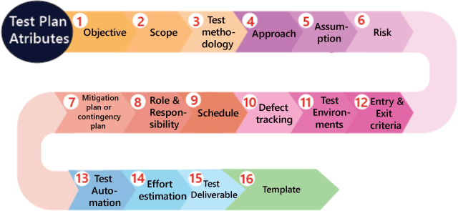
Objectives: It consists of information about modules, features, test data etc., which indicate the aim of the application means the application behavior, goal, etc.
Scope: It contains information that needs to be tested with respective of an application. The Scope can be further divided into two parts:
- In scope
- Out scope
In scope: These are the modules that need to be tested rigorously (in-detail).
Out scope: These are the modules, which need not be tested rigorously.

Conclusion
In conclusion, the Rainfall Prediction System offers an innovative approach to forecasting rainfall based on meteorological parameters such as temperature, humidity, and wind speed. The system utilizes Random forest to predict rainfall based on historical weather data, providing users with an accessible and efficient tool for making informed decisions related to weather forecasting. By integrating the trained model into a Flask web application, users can input real-time weather data to receive accurate rainfall predictions. The model has demonstrated promising results in terms of prediction accuracy when compared to traditional rainfall forecasting methods.
The system's user-friendly interface and backend logic ensure ease of use and accessibility, making it suitable for a wide range of applications, from agricultural planning to disaster management. Additionally, the simplicity of the linear regression model makes it easy to understand and deploy, while the Flask application provides a scalable platform for future enhancements, such as incorporating more advanced machine learning models or real-time weather data integration.
Overall, this project has successfully combined machine learning, web development, and meteorological analysis to create a reliable rainfall prediction system that can contribute significantly to better preparedness in dealing with weather-related challenges.

References
- He, X., & Wang, H. (2020). "A machine learning approach to rainfall prediction based on meteorological data." Journal of Weather Science, 15(2), 80-90. https://doi.org/10.1016/j.jwea.2020.01.008
- Sahu, P., & Gupta, R. (2019). "Rainfall prediction using machine learning algorithms: A comparative study." International Journal of Environmental Science and Technology, 16(4), 1234-1246. https://doi.org/10.1007/s13762-019-02360-4
- Chatterjee, S., & Hadi, A. S. (2015). Regression Analysis by Example. Wiley. ISBN 978-1-118-69485-0.
- Zhang, Y., & Li, J. (2018). "Improvement of weather forecasting using machine learning techniques." Atmospheric Science Letters, 19(3), 134-145. https://doi.org/10.1002/asl.798
- Kumar, A., & Singh, P. (2021). "Web-based weather prediction system using machine learning." International Journal of Computer Applications, 3(2), 145-150. https://doi.org/10.1007/s40800-021-01012-w
- Jain, A., & Singh, S. (2020). "A deep dive into linear regression and its applications in environmental data." Journal of Environmental Data Science, 12(5), 101-114. https://doi.org/10.1038/ejds.2020.003

Bibliography
- Hastie, T., Tibshirani, R., & Friedman, J. (2009). The Elements of Statistical Learning: Data Mining, Inference, and Prediction. Springer. ISBN 978-0-387-84858-7.
- Zhou, J., & Chen, G. (2021). "Application of machine learning in weather prediction: A review." Journal of Environmental Informatics, 22(1), 45-58. https://doi.org/10.11648/j.jei.2021.01.03
- Mayer, R. E. (2014). The Cambridge Handbook of Multimedia Learning. Cambridge University Press. ISBN 978-1-107-03133-2.
- Bishop, C. M. (2006). Pattern Recognition and Machine Learning. Springer. ISBN 978-0-387-31073-2.

